http://www.12sky2-ph.com/web/guide/pet.aspx양식의 맨 위





[](http://www.12sky2-ph.com/)

**[news](http://www.12sky2-ph.com/web/news/announcement.aspx) Tin tức**

* [Announcements](http://www.12sky2-ph.com/web/news/announcement.aspx)
* [Notice](http://www.12sky2-ph.com/web/news/notice.aspx)

**[guide](http://www.12sky2-ph.com/web/guide/story.aspx) Hương dãn Game**

* [Story](http://www.12sky2-ph.com/web/guide/story.aspx)
* [Introduction](http://www.12sky2-ph.com/web/guide/Introduction.aspx)
* [Game Feature](http://www.12sky2-ph.com/web/guide/feature.aspx)
* [System Requirements](http://www.12sky2-ph.com/web/guide/requirements.aspx)
* [General Questions](http://www.12sky2-ph.com/web/guide/questions.aspx)
* [Getting Started](http://www.12sky2-ph.com/web/guide/start.aspx)
* [Class Info](http://www.12sky2-ph.com/web/guide/info.aspx)
* [Game Play](http://www.12sky2-ph.com/web/guide/play.aspx)
* [Pet Information](http://www.12sky2-ph.com/web/guide/pet.aspx)
* [Items](http://www.12sky2-ph.com/web/guide/item.aspx)
* [PvP Combat](http://www.12sky2-ph.com/web/guide/pvp.aspx)
* [Player Interaction](http://www.12sky2-ph.com/web/guide/player.aspx)
* [Government](http://www.12sky2-ph.com/web/guide/government.aspx)
* [NPCs](http://www.12sky2-ph.com/web/guide/npcs.aspx)

**[forums](http://www.12sky2-ph.com/web/community/list.aspx?DIV=discussion) Cộng đồng**

* [General Discussion](http://www.12sky2-ph.com/web/community/list.aspx?DIV=discussion)
* [Tips / Knowhow](http://www.12sky2-ph.com/web/community/list.aspx?DIV=tips)
* [Problem Solution](http://www.12sky2-ph.com/web/community/list.aspx?DIV=problem)
* [Item Trade](http://www.12sky2-ph.com/web/community/list.aspx?DIV=trade)

**[Media](http://www.12sky2-ph.com/web/media/video.aspx) Truyền thông**

* [Video](http://www.12sky2-ph.com/web/media/video.aspx)
* [Artwork](http://www.12sky2-ph.com/web/media/list.aspx?DIV=artwork)
* [Screenshots](http://www.12sky2-ph.com/web/media/list.aspx?DIV=screenshots)

**[Item Mall](http://www.12sky2-ph.com/web/shop/upgrading.aspx) Cửa hàng**

* [Item List](http://www.12sky2-ph.com/web/shop/upgrading.aspx)

**Game Guides**

* [Story](http://www.12sky2-ph.com/web/guide/story.aspx) Câu chuyện
* [Introduction](http://www.12sky2-ph.com/web/guide/introduction.aspx) Giới thiệu
* [Game Feature](http://www.12sky2-ph.com/web/guide/feature.aspx) Trò chơi tính năng
* [System Requirements](http://www.12sky2-ph.com/web/guide/requirements.aspx) Yêu cầu hệ thống
* [General Questions](http://www.12sky2-ph.com/web/guide/questions.aspx) Câu hỏi chung
* [Getting Started](http://www.12sky2-ph.com/web/guide/start.aspx) Bắt đầu
* [Class Info](http://www.12sky2-ph.com/web/guide/info.aspx) Thông tin các phe
* [Game Play](http://www.12sky2-ph.com/web/guide/play.aspx) Chơi Game
* [**Pet Information**](http://www.12sky2-ph.com/web/guide/pet.aspx) Thông tin vật nuôi
* [Items](http://www.12sky2-ph.com/web/guide/item.aspx) Hạng mục
* [PvP Combat](http://www.12sky2-ph.com/web/guide/pvp.aspx) Chiến đấu PvP
* [Player Interaction](http://www.12sky2-ph.com/web/guide/player.aspx) Người chơi tương tác
* [Government](http://www.12sky2-ph.com/web/guide/government.aspx) Chính phủ
* [NPCs](http://www.12sky2-ph.com/web/guide/npcs.aspx) [NPCs](http://www.12sky2-ph.com/web/guide/npcs.aspx)

Home > Game Guides > Pet Information

Pet Information Thông tin vật nuôi

by SUPERManager 20 Aug 2013

PETS Vật nuôi

* Pets provide a wide variety of bonuses to characters. However, they must be fed Heavenly Fruit for these bonuses to take effect, as well as to gain Experience.
* Thú nuôi cung cấp cho nhân vật nhiều tiền thưởng, Tuy nhiên chúng phải được cho ăn trái cây Heavenly thì mới có sức lực.
* **Vespida Wasp**
* 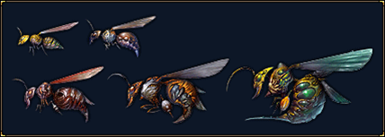
* Required Character Level: 1
* Bonus: Increases Attack
* **Cabochon Relic**
* 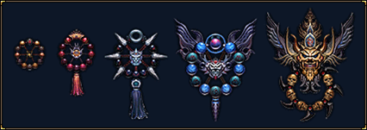
* Required Character Level: 1
* Bonus: Increases Defense
* **Feng Demon**
* 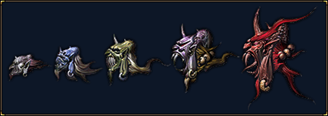
* Required Character Level: 1
* Bonus: Increases Health
* **Imperial Moth**
* 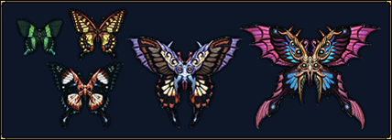
* Required Character Level: 1
* Bonus: Increases Chi
* **Karabos Scarab**
* 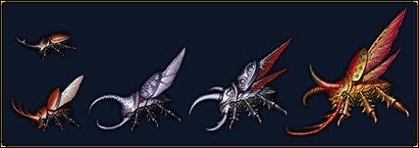
* Required Character Level: M1
* Bonus: Increases Attack and Defense
* **Lamillar Owl**
* 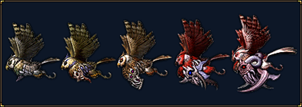
* Required Character Level: M1
* Bonus: Increases Attack and Health Bonus:
* **Bainfu Bat**
* 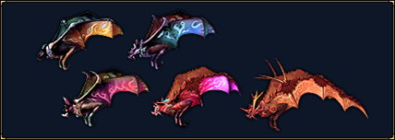
* Required Character Level: M1
* Bonus: Increases Attack and Chi
* **Turtalias Shell**
* 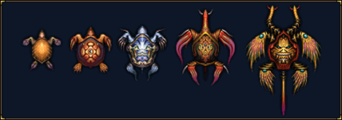
* Required Character Level: M1
* Bonus: Increases Defense and Health
* **Jade Kirin**
* 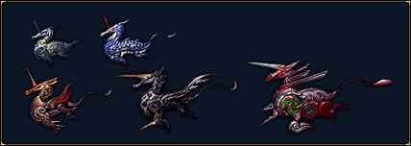
* Required Character Level: M1
* Bonus: Increases Defense and Chi Bonus:
* **Pinyin Spirit**
* 
* Required Character Level: M1
* Bonus: Increases Health and Chi
* **Grace Falchion**
* 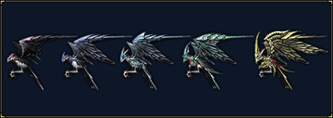
* Required Character Level: M15
* Bonus: Increases Attack, Defense, and Health Bonus:
* **Emperor Phoenix**
* 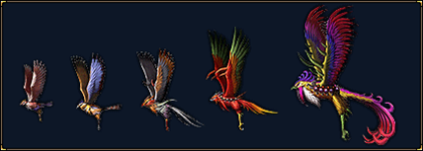
* Required Character Level: M15
* Bonus: Increases Attack, Defense, and Chi
* **Siwang Dragon**
* 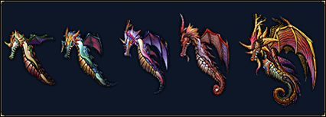
* Required Character Level: M15
* Bonus: Increases Attack, Health, and Chi
* **Geier Vulture**
* 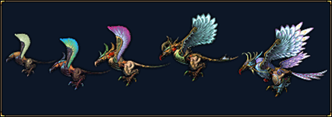
* Required Character Level: M15
* Bonus: Increases Defense, Health, and Chi
* **Verita Leviathan**
* 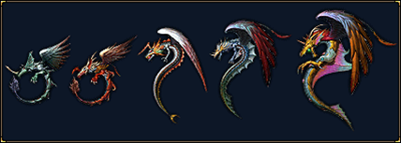
* Bonus: Increases Attack, Defense, Health, and Chi

[top](http://www.12sky2-ph.com/web/guide/pet.aspx)

KJ GAMESCopyright (c) KJ GAMES, All Rights Reserved.

* [Terms of Use](http://www.12sky2-ph.com/web/about/terms.aspx)
* [Privacy Policy](http://www.12sky2-ph.com/web/about/privacy.aspx)

양식의 맨 아래